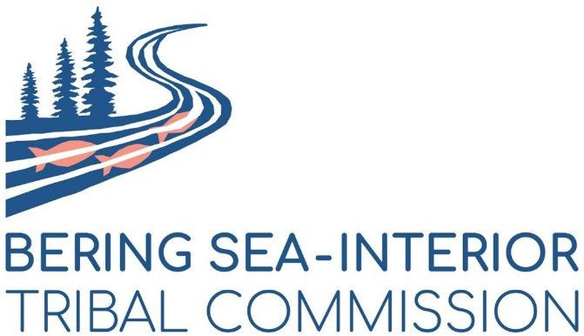

ANNOUNCEMENT
WHAT: All Member In-Person Meeting of the Bering Sea Interior Tribal Commission & Tribal Conservation District

WHEN: All Day Thursday and Friday – May 8 & May 9, 2025 (breakfast and lunch provided)

WHERE: Marriott Hotel, Anchorage (820 West 7th Avenue, Anchorage, Alaska 99501)

Member Tribes may register two delegates to attend in-person.
Register today! Click Here to Register

The Bering Sea Interior Tribal Commission will hold an all-member in-person meeting in Anchorage on May 8th and May 9th, 2025, at the Marriott Hotel in Anchorage.
Member Tribes of the Bering Sea Interior Tribal Commission are invited to register and send two in-person delegates to attend this two-day Being Sea Interior Tribal Commission Meeting from 9 AM to 4 PM both May 8th and May 9th, 2025. Reimbursement benefits are available through the Holy Cross Tribe’s America the Beautiful grant up to $3,500 each for two delegate’s attendance ($7,000 maximum per member Tribe). Receipts must be provided by your Tribe for reimbursement. To qualify for reimbursement of travel, lodging, and per diem, attendance of the full meeting is required.

It is important that member Tribes send at least one representative to attend this meeting, and Tribal delegates may attend online through the virtual link to be provided. A quorum is required to approve any actions.

The meeting will provide a forum for updated information on Tribal Commission goals and include discussion about strategic planning for the Tribal Conservation District that is intended to achieve co-management of Tribally nominated salmon-producing watersheds and other important areas. Please register today.

If you have questions, please contact Rachael Roberson at 907-444-0494 and rachael@landvoicefuture.com ; or contact Suzanne Little at 907-244-2417 and Suzanne@LandVoiceFuture.com

