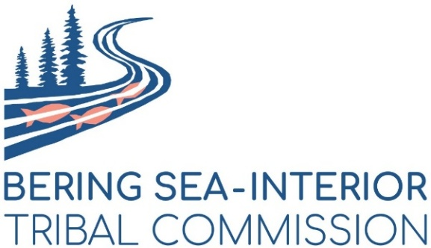

PRESS RELEASE – For Immediate Release (Upon Passage of SJR 63)

CONTACT:
Frank Katchatag, Chairman of the Bering Sea Interior Tribal Commission (907) 625-1609
Mickey Stickman, Executive Board Bering Sea Interior Tribal Commission (907) 378-2102

The Bering Sea-Interior Tribal Commission (Tribal Commission) is a consortium of forty federally recognized Alaska Tribes working in unity to protect and support our traditional ways of life by advocating for land use planning processes and natural resource management decisions that reflect our voices and values. The Central Yukon planning area encompasses our member Tribes’ ancestral homelands and areas that continue to sustain our subsistence-based ways of life.

The Tribal Commission has voiced strong opposition to passage of S.J. Res. 63, the Congressional Review Act resolution to overturn the Bureau of Land Management’s (BLM) 2024 Central Yukon Resource Management Plan (RMP). Overturning the plan guiding the management of 13.3 million acres of BLM-managed lands, will be deeply detrimental to our Tribes’ ways of life and create a great degree of uncertainty for the management of these lands moving forward.

The decision to undo the Central Yukon Plan will have significant impacts on our Tribal communities. The health and well-being of our communities is intrinsically connected to our ancestral homelands, including land now managed by the Bureau of Land Management. BLM-managed lands promote community health, support subsistence opportunities, and sustain the wild food economies our communities rely on. For Alaska Native communities off the road system, over 80 percent of food consumed comes directly from the surrounding lands and waters. BLM-managed lands are critical for providing subsistence hunting, fishing, and gathering opportunities that sustain indigenous ways of life and the wild food economies local communities rely on.

Mickey Stickman, former First Chief of the Nulato Tribe said, “On the heels of the seventh summer without our usual salmon harvest, we are stunned at the idea our leaders would impose more uncertainty around the management of the lands that surround us. The threat of losing our federal subsistence rights, and confusion over how the caribou, moose, and salmon habitat will be managed, is overwhelming,” said Mickey Stickman former First Chief of the Nulato Tribe. “Despite deep involvement and over a dozen years of going to meetings and government-to-government consultations, our voices are being silenced and the future of our food security thrown up in the air.”

Overturning this plan will eliminate protections for the fish and wildlife that support our cultural, economic, and social health. Lands in the Central Yukon planning area are critically providing subsistence hunting, fishing, and gathering opportunities that sustain our ways of life and feed our communities. Decisions about these lands should not be made without meaningful engagement with our Tribal communities, yet Congress has acted without consulting us.

The Bering Sea Interior Tribal Commission strongly believes that the Congressional Review Act should not be applied to resource management plans because plans take 5-10 years and a great deal of effort to complete plans. The BLM is required by law to keep a current inventory of lands and resources and to update resource management plans.

With the passage of Senate Joint Resolution 63, all 13 million acres of land governed by the Central Yukon plan will now revert to management under three separate old plans that date back more than three decades. There will be no clarity for developers. There will be no assurances for Tribes. And the BLM, by law, will have to start all over again to create a current plan for management of this land, causing chaos and confusion for land managers, developers, and Tribes who live directly with this land.

